**IoT Based Noise Pollution Monitoring System**

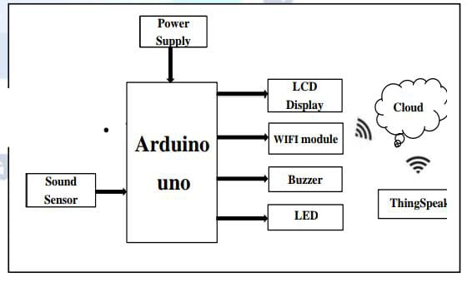 **Phase 4**

**COMPONENTS**

1. ArduinoUNO

2. LM393 (Noisesen

3. ESP8266 WIFIModule

4. 16*2 LCDDisplay

5. LED

6. Buzzer

1. **ArduinoUNO**

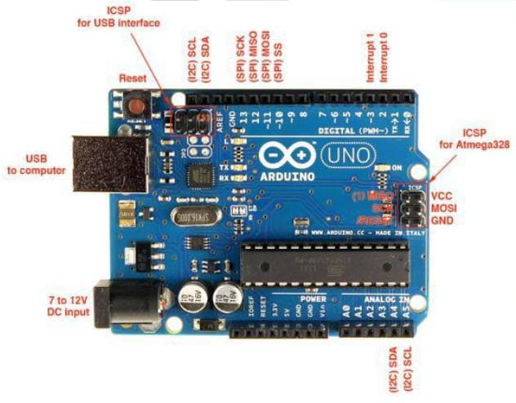

Arduino is 8 bit microcontroller board based on the ATmega328P. The operating voltage is 5V. It has 14 pins digital input output pins (Of which can be used 6 as PWM output)Oscillator frequency is 16 MHz It contains everything needed to support the microcontroller simply connect it to a computer with USB cable. It has 6 analog input pins.

**Features**

• Operating voltage is5v.

• DC current per input pin is 40mA.

• Clock speed16MHz.

• DC current for 3.3v pin is 50mA.

• SPAM 2 KB

• EEPROM 1KB

1. **LM393 (Noise sensor)**

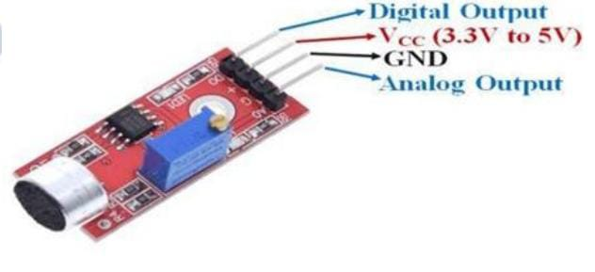

The sound sensor module provide an easy way to detect sound and it generally used for detecting sound

intensity. Module detect the sound has exceeded a threshold value. Sound is detected via microphone and fed into an LM393 opamp. The sound level adjust through pot. The sound increases set value output is low.These module work on DC 3.3-5 voltage.

**Features**

• Operating voltage 3.3V-5V

• Output model: digital switch outputs (0 and 1, high or low level)

• Voltage Gain 26dB

• Microphone Impedance 2.2kΏ

• Microphone Frequency 16.20 kHz

1. **ESP32 or ESP8266 WIFIModule**

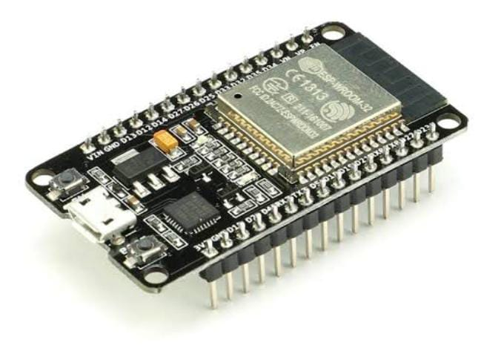

The ESP32 or esp8266 WIFI module is a self containedsoc with integrated TCP/IP protocol stack that can give any microcontroller access to your WIFI network. The ESP32 or esp8266 is capable of either hosting an application or offloading all WIFI networking functions from another application processor.

**Features**

• 2.4 GHz Wi-Fi (802.11 b/g/n supporting WPA/WPA2).

• General-purpose input/output (16 GPIO).

• Inter-Integrated Circuit (I²C) serial communication protocol.

• Analog-to-digital conversion (10-bit ADC).

• Serial Peripheral Interface (SPI) serial communication

1. **16*2 LCDDisplay**

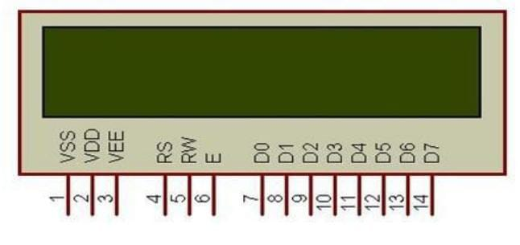

LCD is used for to display the condition there are three conditions in air pollution and three conditions in noise pollution means air and sound is clear, moderately polluted or highly polluted that is displayed on LED.

**Features**

• Operating Voltage is 4.7V to 5.3V

• Current consumption is 1mA without backlight

• Alphanumeric LCD display module, meaning can display alphabets and numbers

• Consists of two rows and each row can print 16 characters.

• Each character is build by a 5×8 pixel box

• Can work on both 8-bit and 4-bit mode

1. **LED**

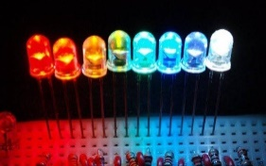

light emitting diode (a device that produces a light on electrical and electronic equipment).

1. **Buzzer**

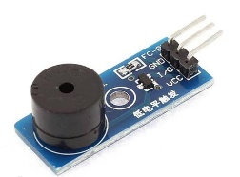

An Active Buzzer Alarm Module easily interfaced with an Arduino or other microcontrollers is an audio signaling device, which may be mechanical, electromechanical, or piezoelectric. Just like what you are viewing now, it is 3.3V to 5V DC power supply Electronic Part Active Buzzer Module.

**ALGORITHM**

1. Start Arduino UNO.

2. initialize LCD, gas sensor & noise sensor

3. Establish WITI connections.

4. If connection successful. next step else go to step 1

5. Read sensor values.

6. If Sensor value available establish TCP connection else read values again.

7. Establish TCP connection

8. If TCP connections successful. send data to server (Thing speak). else set go to step 7

9. If TCP connections successful. send data to server (Thing Speak). else set gob to step 7

10. Check for acknowledgement.

11. If acknowledgement received. go to step some time & else wait for go to step no 5.

**ADVANTAGES**

1. Sensors are easily available.

2. Sensors are effortlessly accessible.

3. Simple, compact and easy to handle.

4. Sensors have long life time.

5. Low cost

6. Data can be used to control pollution.

**APPLICATIONS**

1. To estimate the pollution.

2. To design server and upload data on that server with date and time.

4. We can use it at industrial area as there is lot of noise pollution

5. In city roads traffic noise.

6. Automation Automation.

**FUTURE SCOPE**

In future we modify the system to notify a user about the noise level it reaches beyond permissible level through sms or app. We can monitor sound pollution level at any place of the world.

**PROGRAM**

import time

import sys

import struct

import getopt

import threading

import usb1

class Bafx3608:

"""BAFX3608 Sound Pressure Level meter USB driver"""

USBVendorID = 0x64bd

USBProductID = 0x74e3

OUT_ENDPOINT = 0x02

IN_ENDPOINT = 0x81

RANGE = ['30-130', '30-80', '50-100', '60-110', '80-130', 'invalid', 'invalid', 'invalid']

WEIGHT = ['A', 'C']

MAXMODE = [' ', 'Max']

FASTMODE = ['Slow', 'Fast']

def __init__(self, fast=True, maxmode=False, weightC=False, dBrange=0):

self.options = (fast << 6) | (maxmode << 5) | (weightC << 4) | dBrange

self.thread_id = -1

self.cb_on_reading = None

self.cb_on_reading_str = None

self.cb_on_reading_raw = None

self.handle = None

def set_config_usb(self):

"""

set_config_usb() writes BAFX3600 meter options over USB

"""

# Write meter options

command = bytearray([0x56, self.options, 0, 0, 0, 0, 0, 0])

while True:

try:

self.handle.interruptWrite(Bafx3608.OUT_ENDPOINT, command, 10)

break

except usb1.USBErrorTimeout:

pass

def set_config(self, fast=True, maxmode=False, weight_c=False, db_range=0):

"""

set_config(fast=True, maxmode=False, bool weight_c=False, db_range=0)

"""

self.options = (fast << 6) | (maxmode << 5) | (weight_c << 4) | db_range

self.set_config_usb()

def get_config(self):

"""

get_config() return BAFX3608 options as bitmap

"""

return self.options

def loop_start(self):

"""

Start thread reading from meter

"""

if self.thread_id == -1:

self.thread_id = threading.Thread(target=self.usb_poll_thread)

self.thread_id.start()

def loop_forever(self):

"""

Read from meter blocking. Does not return.

"""

self.usb_poll_thread()

def _eval_data(self, usbdata, fast_mode):

if usbdata is not None and len(usbdata) > 2:

decibels, options = struct.unpack_from('>HB', usbdata)

decibels = decibels / 10

if decibels <= 130.0:

fast_mode = (options & (1<<6)) != 0

max_mode = (options & (1<<5)) != 0

ac_mode = (options & (1<<4)) != 0

inrange = options & 0x07

if self.cb_on_reading_raw is not None:

self.cb_on_reading_raw(usbdata[:3])

if self.cb_on_reading is not None:

self.cb_on_reading(decibels, fast_mode, max_mode, ac_mode,\

inrange)

if self.cb_on_reading_str is not None:

db_str = f"{decibels:5.1f}"

fast_mode_str = f"{self.FASTMODE[fast_mode]}"

max_mode_str = f"{self.MAXMODE[max_mode]}"

self.cb_on_reading_str(db_str, fast_mode_str, max_mode_str, \

f"{self.WEIGHT[ac_mode]}", f"{self.RANGE[inrange]}")

return fast_mode

def usb_poll_thread(self):

"""

Meter reading thread

"""

self.handle = usb1.USBContext().openByVendorIDAndProductID(

Bafx3608.USBVendorID,

Bafx3608.USBProductID,

skip_on_error=True,

)

if self.handle is None:

# Device not present, or user is not allowed to access device.

print('Device not present')

sys.exit(1)

if self.handle.kernelDriverActive(0):

self.handle.detachKernelDriver(0)

self.handle.claimInterface(0)

try:

self.set_config_usb()

# Read sound levels from meter

command = bytearray([0xb3, 0xaa, 0xbb, 0xcc, 0x00, 0x00, 0x00, 0x00])

fast_mode = True

while True:

try:

self.handle.interruptWrite(Bafx3608.OUT_ENDPOINT, command, 20)

data = self.handle.interruptRead(Bafx3608.IN_ENDPOINT, 8, 10)

fast_mode = self._eval_data(data, fast_mode)

except usb1.USBErrorTimeout:

pass

except usb1.USBErrorOverflow:

pass

except usb1.USBErrorPipe:

pass

except usb1.USBErrorNoDevice:

break

if fast_mode:

time.sleep(0.250)

else:

time.sleep(1.0)

finally:

try:

self.handle.releaseInterface(0)

self.handle.close()

except usb1.USBErrorNoDevice:

pass

def main():

"""

main program

"""

help_cli = f'{sys.argv[0]} --range=[0..4] --fast=[0,1] --max=[0,1] --weight=[A,C]'

out_range = 0

out_fast = 1

out_weight = 0

out_max = 0

try:

opts, _args = getopt.getopt(sys.argv[1:], '', ['range=', 'fast=', 'weight=', 'max='])

except getopt.GetoptError:

print(help_cli)

sys.exit(2)

try:

for opt, arg in opts:

if opt == '--range':

out_range = int(arg) & 0x07

elif opt == '--fast':

out_fast = int(arg) & 0x01

elif opt == '--weight':

out_weight = 0

if arg in ('C', 'c'):

out_weight = 1

elif opt == '--max':

out_max = int(arg) & 0x01

except ValueError:

print(help_cli)

sys.exit(2)

def reading_callback_str(decibels, _fast, maxmode, weight_c, db_range):

"""

callback

"""

print(decibels, "dB" + weight_c, maxmode, db_range)

meter = Bafx3608(out_fast, out_max, out_weight, out_range)

meter.cb_on_reading_str = reading_callback_str

meter.cb_on_reading = None

meter.cb_on_reading_raw = None

meter.loop_forever()

if __name__ == "__main__":

main()

**CONCLUSION**

By using this project each and every variation we can analyze and inform nearby people in time. We can also analyze data form home using thingspeak. The most important factor of this system is that it is

small, cost efficient and portable. Sensors are available easily anywhere. This system fully helpful to save the lives and overcome all the problem related to environment.